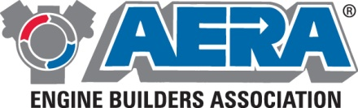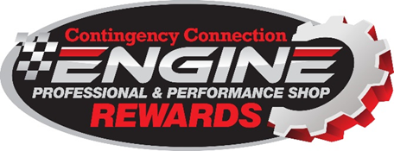

2022 AERA Engine Professional Rewards Sponsors

- ACC Performance
- ACCEL
- Advanced Sleeve
- AERA Engine Builders Association
- AIR FLOW RESEARCH (AFR)
- ATM Innovation
- AUTOMETER
- BULLY DOG
- Canton Racing Products
- Champ Pans
- CLEVITE
- CLOYES
- Comp Cams
- DART Heads
- Daytona Sensors
- DEDENBEAR Products
- Demon Carburetion
- DERALE Performance
- DIAMOND Pistons
- E3 Spark Plugs
- Eagle Specialty Products
- Earl’s Performance
- Edelbrock
- Edelbrock Blocks
- Elgin Industries
- Elgin Push Rods
- ERSON Cams
- FAST
- FIRMAN Power Equipment
- Flowmaster
- G-FORCE Racing Gear
- Hamburger’s Performance
- HAWK Performance
- Holley Performance
- Hooker Headers
- IDIDIT Steering Columns
- INNOVATE Motorsports
- JE Pistons
- JMS Chip & Performance
- K1 Technologies
- Liberty Performance Components
- LINCOLN Welders
- LOCKRIGHT
- Magnecor
- MAHLE Motorsports
- Manley
- MAXFIRE IGNITION by Edelbrock
- Melling Select Performance
- MELL-GEAR
- Milodon
- Moser Engineering
- Motive Gear
- Mr. Gasket
- MSD Ignition Control
- NANO Ceramic Robertson Racing
- NOS
- OSC Heat
- Pac Springs
- PACER PERFORMANCE
- Painless Performance
- PBM Performance Products
- Powertrax
- PROCAR SEATS by Scat
- Quick Fuel Technology
- Race Gas
- RaceCals
- Racing Radios
- Renegade Race Fuel, Oil, Lubricants
- Richmond Gear
- Rottler
- Russell Performance Plumbing
- SCAT
- SCT Performance Tuning
- SPA Technique Fire Suppression
- SRP Piston Kit
- STACK LTD
- Stage 8 Locking Fasteners
- Taylor Cable Products
- TCI Automotive
- Ten Factory
- THERMO-TEC
- Trans-Dapt Performance
- TREND Performance
- USMW HD
- USMW Professional
- WEIAND
- WISCO Performance
- WORLD Products

